[5:-10] (array([-28.86133299, 29.79042851]), array([[ 0.05357647, -0.07501875],

[-0.07501875, 0.10506248]])) 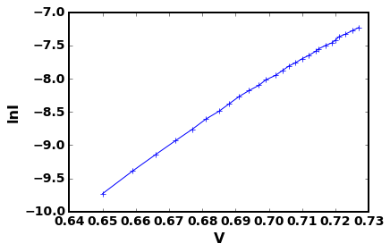

[6:-10] (array([-28.8329942 , 29.75083588]), array([[ 0.05326067, -0.07455699],

[-0.07455699, 0.10438813]])) 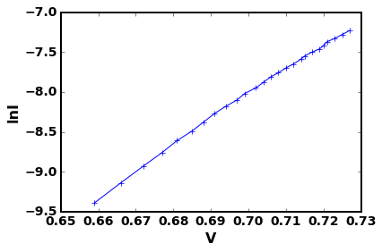

[7:-10] (array([-28.75612874, 29.64345274]), array([[ 0.05002148, -0.07002825],

[-0.07002825, 0.09805476]])) 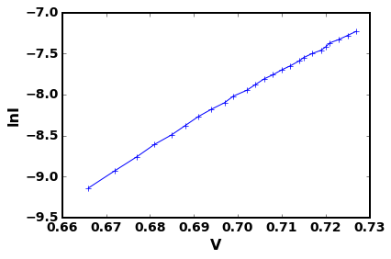

[8:-10] (array([-28.69825601, 29.56262903]), array([[ 0.04899781, -0.06859392],

[-0.06859392, 0.09604415]])) 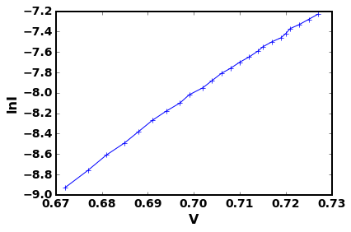

[9:-10] (array([-28.59430322, 29.41751588]), array([[ 0.04568531, -0.06394169],

[-0.06394169, 0.08950839]])) 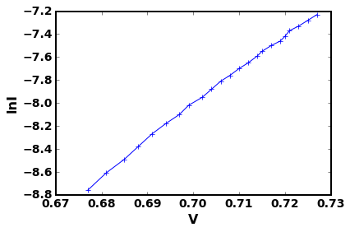

[10:-10] (array([-28.49756387, 29.28251597]), array([[ 0.04343824, -0.06080147],

[-0.06080147, 0.08511842]])) 